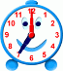
1:00
2:00
3:00
4:00
5:00
6:00
7:00
8:00
Name:

