Cut and Paste Practice

Orange
Green
Yellow
Purple
Brown
Black
Pink
Grey
Blue

Hello Kitty
Nemo
Rex
Dora
SpongeBob
Pink Panther
Buzz Lightyear
Pingu
Arthur
Clifford

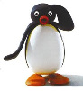 | 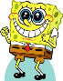 | 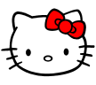 | 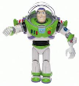 | 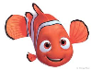 | 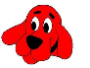 | 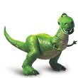 | 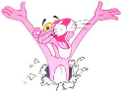 | 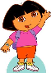 | 