Name:

Font Format Practice
- Make this sentence bold.
- Underline this sentence.
- Change the font size of this sentence to 24.
- Change the color of this sentence to orange.
- Make this sentence italic.
- Double underline this sentence.
- Use strikethrough formatting on this sentence.
- Change the color of this sentence to blue.
- Change the font size of this sentence to 72.
- Use the highlighter to highlight this sentence in yellow.

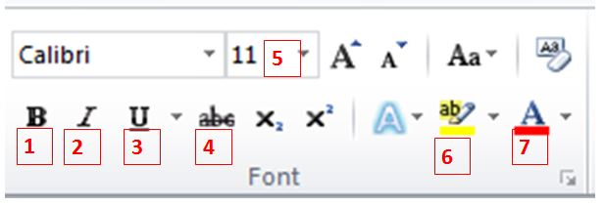
Word Bank
Highlight
Font Size
Italic
Font Color
Bold
Underline
Strikethrough

Type the name of each font formatting tool in the boxes below. The first one is done for you.

1. | Bold
2.
3.
4.
5.
6.
7.

