November High Temperatures Line Graph: Comparing Observed with Average
- Enter the following in the header row:

- In cell A2, enter November 1, 2011. Use the auto fill tool to fill in dates through November 15, 2011 in column A.
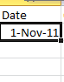
Click the corner and drag down to fill the dates

- Use the link provided on our website to obtain the observed high temperature for each date and enter them in column B. Tile your windows side-by-side so you can view both for easy data entry.
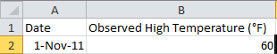
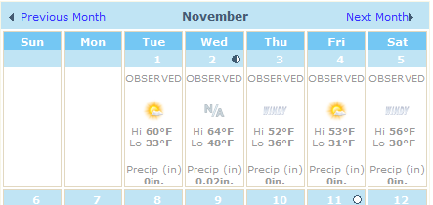

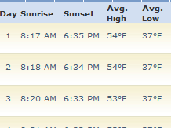
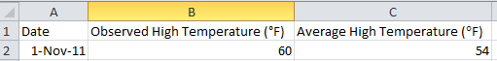
- Visit the link provided on our website to obtain the average high temperature for each date and enter the values in column C. Tile your windows side-by-side so you can view both for easy data entry.

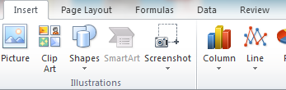
- After entering the temperatures, highlight all cells containing data and click insert and then the line button. Select the first 2-D line chart.

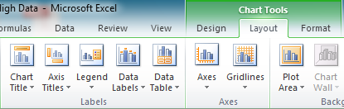
- After you’ve inserted a line chart, add the titles shown below.

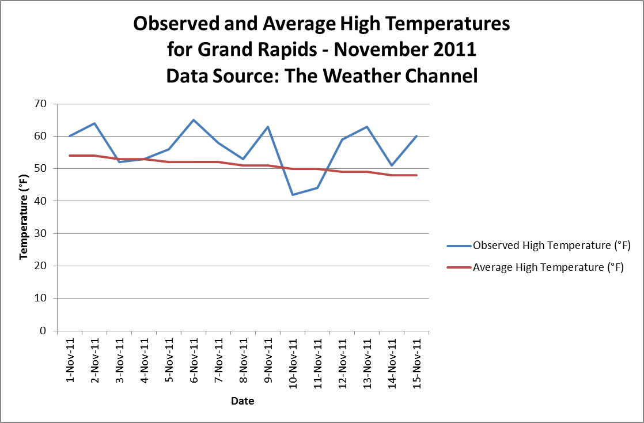
Your line graphs will appear here.

Completion Checklist
☐I entered the header row labels correctly.
☐I entered the correct observed and average temperature for each day November 1-15.
☐I inserted a line graph and increased the size of the chart area appropriately.
☐I added the correct chart title, x-axis label, and y-axis label.

