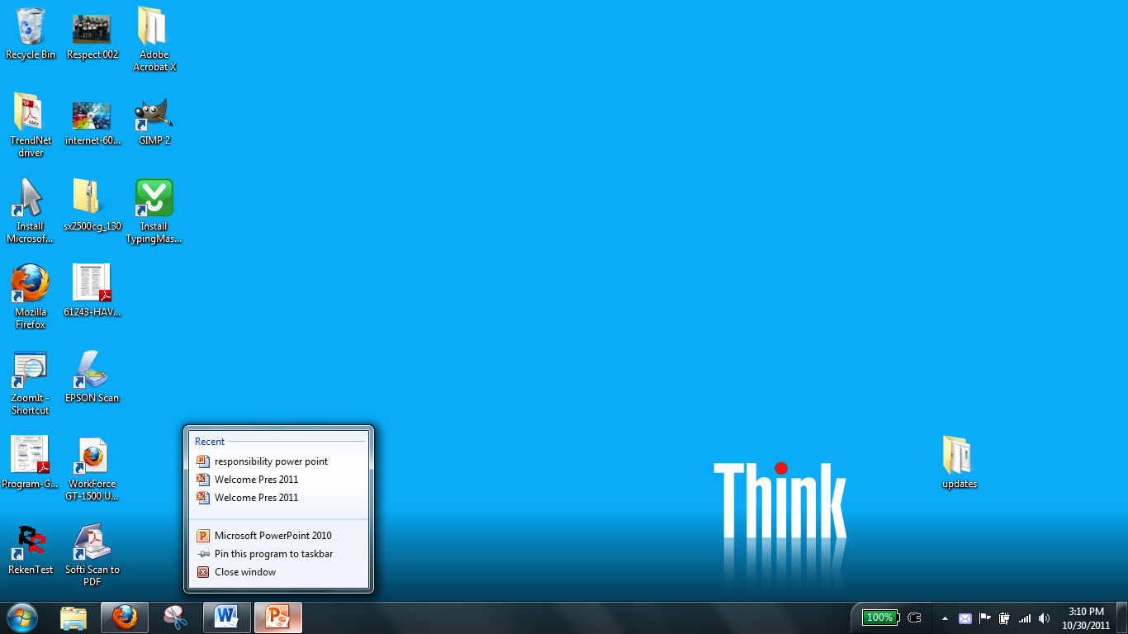

Desktop System Tray Start Button Icons Taskbar Jump List

Name: